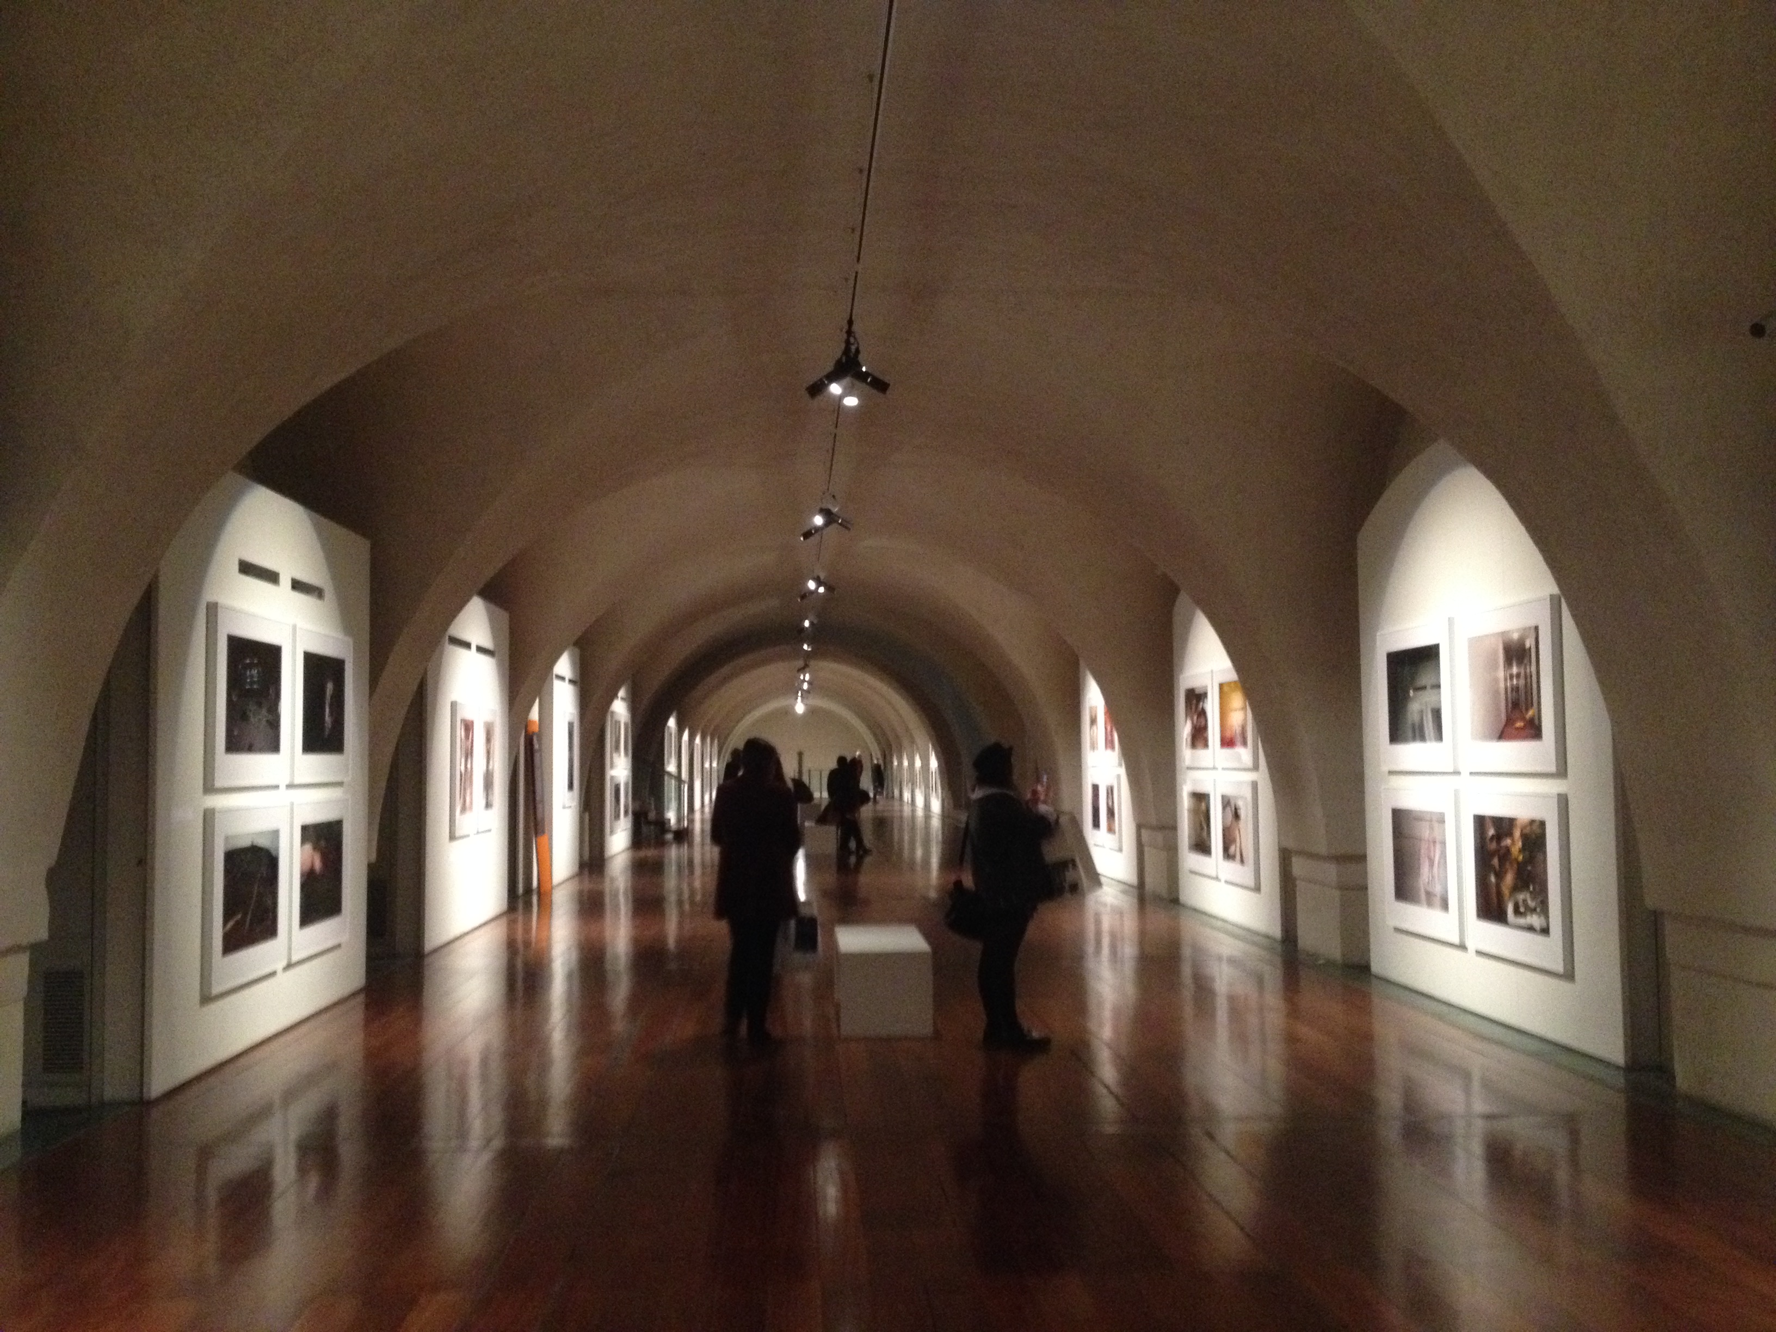

The Image Maker Revealed
“Guy Bourdin: Image Maker” at Somerset House!
By Coleen MacPherson
March 11, 2015

http://www.somersethouse.org.uk/visual-arts/guy-bourdin

“Guy Bourdin: Image Maker” at Somerset House, expands the definition of the infamous French fashion photographer Guy Bourdin. Inspired by surrealism (he was the protégé of Man Ray) Bourdin transformed photography in the 1970s and was made famous especially for his work for Charles Jourdan, where his images were published in countless Vogue editorials. This unique look into his work invites the viewer to see the artist’s process: to see original film footage, sketches, unpublished photographs and polaroids of locations –the hidden Bourdin is revealed while the viewer is also jostled through his filmic, sexy, wild and powerfully suggestive images.

The exhibition begins in Britain, tracing the famous trip Bourdin took with his family across the country in a black Cadillac with a pair of mannequin legs and a suitcase full of shoes. Here he places the mannequin legs against the backdrops of Britain: train station, bus stops, fields, poolsides, crossing a cobblestone street, awaiting a black cab. These photographs in particular ignite the imagination, teetering off balance, suggesting movement - for Bourdin invites the viewer to finish the image – and so, we are all the image-makers and photographers in his world.

Several rooms reveal unpublished photograph, alongside famous Vogue spreads, a film is projected on a Super 8 camera giving us some insight into his process. Bourdin always searched for a location as a backdrop for his models, enhancing his worlds through various techniques – to create filmic worlds that are imbued with story; models hidden, only legs or lips or hands revealed for example.

Wandering through his photographs was like passing through dreams and nightmares, for a Bourdin photograph is always darkly witty, invoking us to imagine ‘what has happened?’ or ‘what will happen?’
Themes, obsessions and techniques are revealed. Leaving the viewer satisfied having witnessing a true artist and image maker – Guy Bourdin, not only known for his commercial work, but for his work as the artist who captures the world.

